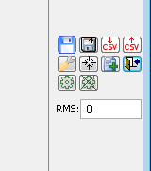

2: Options / Accept

1: Teste
3: Finish

